Access Guide for asses.masses
last updated: 2024.04.25

This document is an introduction to the video game performance experience asses.masses.
It provides an overview of what to expect during the experience, how you can participate, and the accessibility features of the performance.
This guide is a living document and will continue to be updated by our team.
If you have any questions please send us an email at asses.masses.team@gmail.com

TABLE OF CONTENTS
- Access Overview

- About asses.masses
  - Creative Description
  - Glossary of Terms

- What Happens in the Experience

- Accessibility
  - Relaxed Performance Environment
  - Intermission/Breaks
  - Visual Text
  - The Controller
  - Motion Sickness Warning
  - Screen Fatigue
  - Content Advisory

- Episode Guide (contains very big spoilers)

Access Overview
- THEATRE
  - All performances of asses.masses are ‘extra live’, which means that audience members are free to make noise, call out, eat, drink, enter/exit, and move about as needed.
    - Jump to Relaxed Performance Environment

- AUDIO-VISUAL
  - asses.masses requires that players listen for audio cues, read text from the screen, and use their hand dexterity to operate a game controller. The pace of the game is directly controlled by the player and can change depending on the audiences; this includes how quickly players progress through the text.
    - Jump to Visual Text
    - Jump to The Controller

- PARTICIPATION:
  - Many types of participation are welcome, and are often unique to the player.

- MOBILITY:
  - The performance space will be set up to ensure the controller is accessible to wheelchair users, and chairs will be available to support players who cannot stand for long periods of time.

About asses.masses
asses.masses is a custom-made video game that has been designed to be played on stage by a live audience in a theatre. It tells the story of a herd of unemployed donkeys (otherwise known as asses) who leave their life on the farm to try and get their jobs back from the humans.
As an experience, asses.masses is a collaborative journey for the audience where the video game is played from beginning to end in one sitting, over 7+ hours and 10 episodes. It is a one player video game where one person (at a time) uses the controller and the other audience members watch the story unfold, cheer the player on, offer suggestions, and help make decisions.
You can expect the show to feel like a blend of a game night at a friend’s house, with a hint of an epic movie marathon, with a serving of some delicious food, and a healthy mix of political uprising.

Creative Description

asses.masses follows the epic journey of a herd of unemployed asses as they navigate the perils of a post-Industrial society in which they’ve been made redundant.

Each night brave spectators take turns stepping forward to seize the means of production (controller) and become the player. There are no instructions. It is up to each audience and their self-elected leaders to work together to play out their version of the story.

Told across 10 episodes and through a wide range of game forms, including 2D RPG, Platformer, Rhythm Game, 3D Action Adventure, and many more (see Glossary below for details), the asses (and the live audience) must to work together to confront its growing division between those who, harbouring nostalgia for ‘the old ways’, reject technology and those who embrace technology as an adaptation for surviving the present.

Cheeky, political, and best described as Animal Farm meets Aesop’s Fables retold by Franz Kafka, Karl Marx, and Sonic the Hedgehog, asses.masses puts the control(ler) in its audience’s hands and asks them to discover the space between the work that defines us and the play that frees us.

Creative Team
asses.masses is led by Patrick Blenkarn and Milton Lim. Coming from a mixture of performance training (devised and experimental theatre), reading and research (philosophy/psychology), as well as digital media (game engines and real-time interactive systems), Patrick and Milton’s collaborations have manifested in video game performance experiments, participatory installations, digital archives, and card games.

The international team of artists behind the project are:

Patrick Blenkarn (Canada) — co-direction, text, programming, pixel art, 2D animation
Milton Lim (Canada) — co-direction, text, sound design, video, shaders, 3D visual effects
Laurel Green (Canada) — dramaturgy, text, touring producer
David Mesiha (Canada) — original music, sound design
Clarissa Picolo (Brazil) — pixel art, 2D animation, Portuguese translation
William Roth (France) — pixel art, 2D animation
Ariadne Sage (Germany) — 3D environments
Samuel Reinhart (USA) — additional programming
Marcos Krivocapich (Argentina) — Spanish translation
Gilles Poulin-Denis (Canada) — French translation
Julius De Michelis (Italy) — Italian translation
To learn more visit assesmasses.work

Glossary of Terms

RPG: Stands for Role-Playing Game. Players inhabit characters, explore worlds, and complete quests to progress through the story.
Example: Pokemon.

Platformer: Players use technical skill to help their video game character run and jump to overcome obstacles and reach a goal.
Example: Super Mario Bros.

Rhythm Game: Players hit buttons in rhythm with awesome music and awesome visuals.
Example: Dance Dance Revolution.

3D Action Adventure: Players run through beautiful 3D worlds, jumping, fighting against monsters, and exploring the unknown.
Example: Zelda: Ocarina of Time.

Controller: A game controller is a handheld device used to provide input to a video game, typically to control an object or character in the game. asses.masses uses a PlayStation 4 Dual-Shock controller.

Player: The audience member who is using the controller to play the game.

Video Game: An electronic game that involves interactions with an input device (controller) to generate audiovisual feedback on a screen. There is often a story (narrative), characters, action, many choices to make, puzzles to solve, and lots to explore.

Ass or asses: Donkey and ass can be used interchangeably to refer to the animal Equus asinus (this is the scientific name for a donkey). We use the term asses to refer to the herd of donkeys who are the main characters in our story.

What happens in the Experience?
Importantly: You do not have to like, or appreciate, or have even played video games before in order to participate in asses.masses.
You can decide throughout the experience if you would like to use the controller and play, or if you would like to watch others play the game. You can change your mind at any time.
Think of asses.masses like a group coming together at someone’s house to binge-watch the newest series or have a marathon of their favourite films. Many of us do this all the time—we just don’t all have 100 friends and a theatre to use!
There are no actors in asses.masses and there is no one that will tell you what to do during the performance. The players—that’s you—will decide how to play the game, who will play (one person at a time), and make all of the choices for the characters through the game.
When you enter the theatre, you will find a seat in the audience. There will be a game controller on a plinth at the front of the audience in front of a large screen. When the first player takes the controller, the game begins. It cannot be stopped once it has begun, but there are FOUR intermissions available to the audience through the game experience.
For a complete walkthrough of the game, please read the story of asses.masses section below. Please note that this section contains SPOILERS and information that might change the way you experience the performance.
During the show, you can expect an asses.masses audience to be:
- playing the game for at least 7hrs
- calling out to offer or request help
- taking turns with the controller
- laughing because it’s funny and full of wordplay
- crying particularly at the end
Keys to a successful asses.masses experience:
LONG DURATION: Once the game starts, the audience will take the time it requires to complete the game. The show cannot be interrupted after it begins and the creators of the project or the staff from the venue will not intervene. Note that every audience will play the game differently but it will take at least 7 hours to finish.
INTERMISSIONS: There are four intermissions available throughout the show, occurring approximately every two episodes.
FOOD AND DRINKS: We invite audiences to eat and drink throughout the experience. Please check when you buy your ticket to the show whether or not food has been included or is on sale at the venue. We try to make sure there’s snacks and beverages for sale through the evening.

Accessibility

Relaxed Environment
All performances of asses.masses are ‘extra live’ or a relaxed environment, which means that it’s ok to make noises, move around a little more, use devices that help you participate and just be a human in the space with other humans. The theatre is never completely dark except for one moment of blackout at the beginning of the show. Instead, lighting stays at approx. 25-40% to ensure visibility within the audience.

We encourage players to stay in the theatre space and stick with the story until the four intermissions that are offered approximately every 2 episodes. The story of asses.masses is complex, expansive, and not to be missed! Try to wait until an intermission to leave the space, and immerse yourself in the unfolding narrative.

The set up in the theatre will typically look like this with the audience in theatre seats that are facing a big screen. The player will be positioned in front of the audience, so watching the game will look like this:

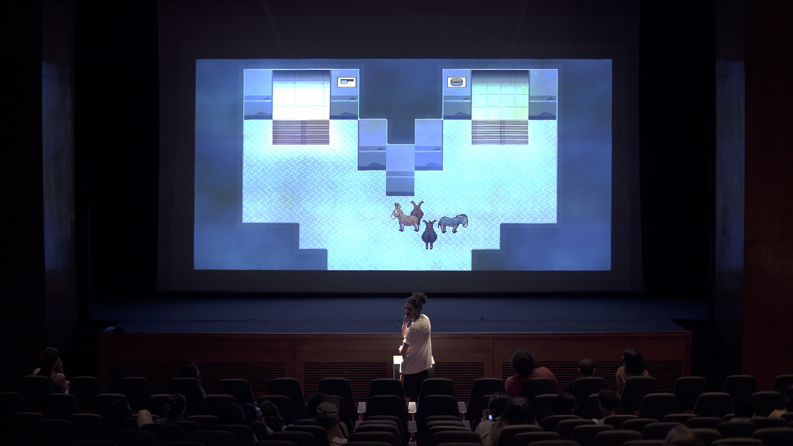

Visual Text

The story of asses.masses is told through visual text, which is delivered on screen in dialogue boxes that are controlled by the player, who presses the X button on the controller to advance to the next action/dialogue. There are no voice over or actors performing the text aloud, and you have to read it for yourself. The pacing of how quickly the text moves is up to the player. If they are going too quickly for you to read, we encourage you to ask them to slow down.

There are two styles of dialogue boxes that are used in the game:

When in 2D, the text looks like this:
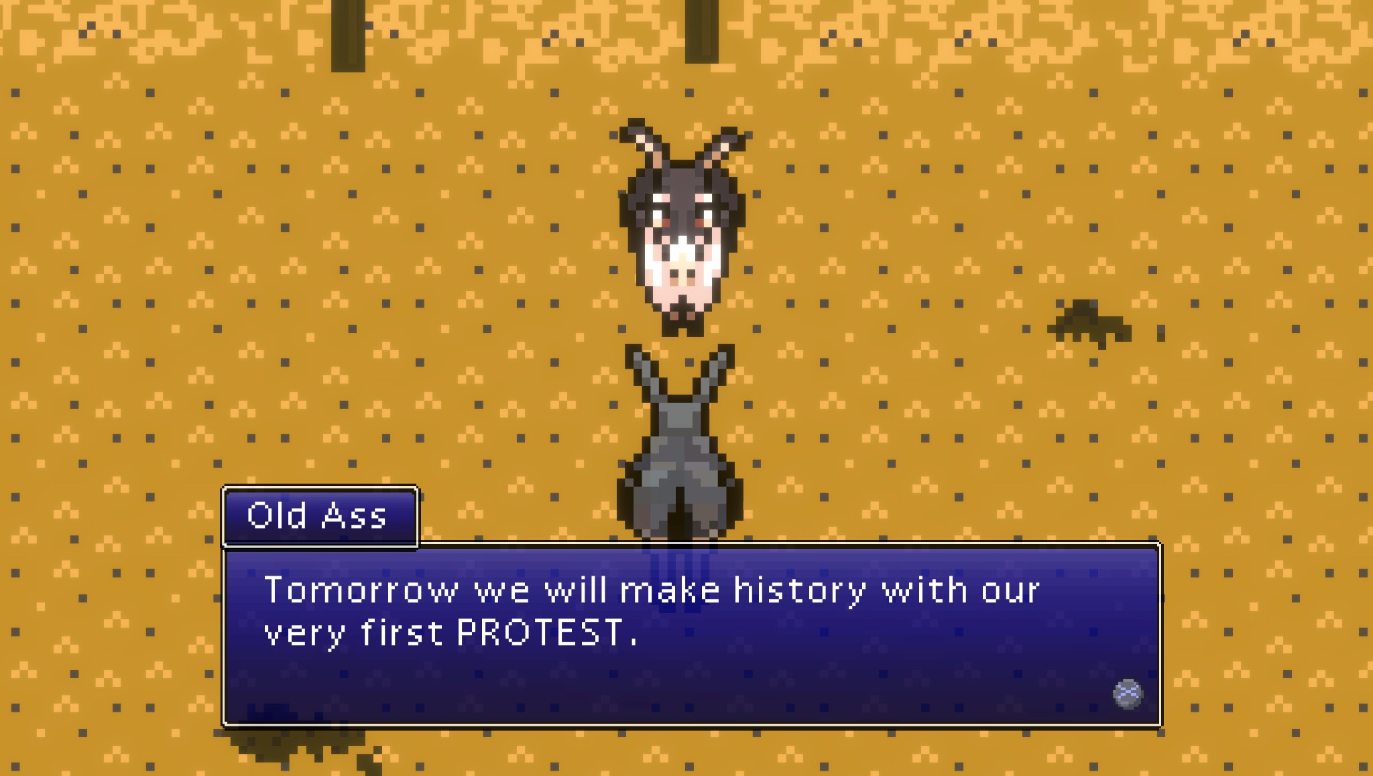

And in the 3D world the text looks like this:

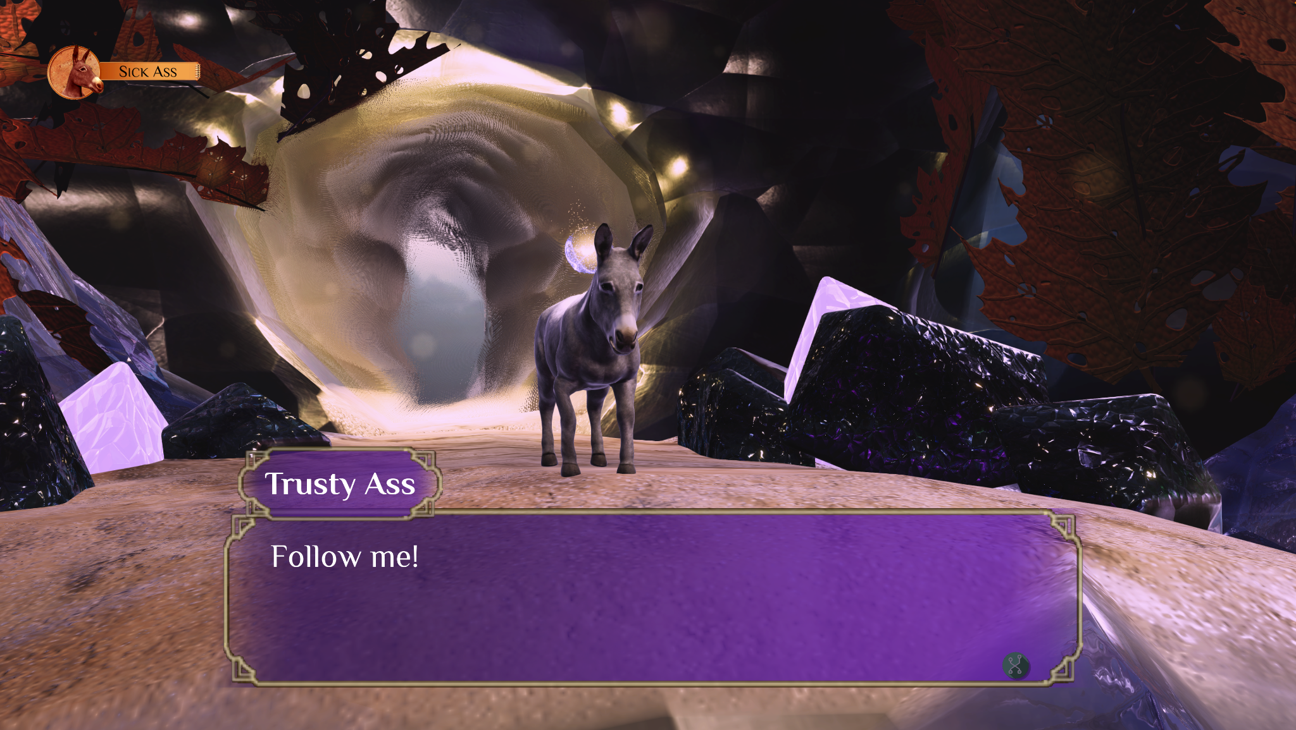

The Controller
The game is played using a PlayStation 4 (PS4) controller, which is provided. This requires holding the controller with two hands, the player pressing buttons, and, for some parts, a certain level of dexterity. A PS4 controller features two joysticks, four trigger buttons, a directional pad, an option button, a share button, plus triangle, cross/x, circle, and square buttons.

The controller looks like this:

We encourage the players to try the buttons and learn from each other to figure out how to move the character and interact with the world. Sometimes during the game you will see an icon pop up on the screen to let you know which button to press.

Motion Sickness Warning
asses.masses contains moments of game play that simulate the sensation of speed and movement in a 3D environment. This may cause dizziness or motion sickness for some audience members. Some people may experience discomfort (such as eye strain, eye fatigue or nausea) while watching 3D video images. We encourage players to take breaks and change seats as needed, and to get the attention of a venue staff member should they require additional care.

Screen Fatigue
asses.masses is projected on a large screen within the theatre. Some spectators may find that the duration of looking at the screen is tiring on their eyes, or even able to provoke headaches. If you are prone to such headaches or have difficulty with screens after extended hours, we recommend you take the necessary breaks to give your eyes a rest throughout the experience. You can ask a Comrade, or consult the episode guide below, to fill you in on any story developments you might have missed

Content Advisory
asses.masses contains coarse language, representations of donkeys mating, loud music, flashing lights, audience participation, and strong revolutionary rhetoric. We recommend it for audience members ages 14 and up. This is not a performance that is suitable for young audiences.

Participation and active spectatorship is a central part of asses.masses. We invite you to be part of our Herd in any way you can.

Episode Guide (contains spoilers)

This episode guide is a synopsis of the story of asses.masses with warnings throughout for moments of loud sound, flashing visuals, or surprises that a member of the audience might want to know about in advance of the show. Please read with care as it reveals key plot points in the story of the game.

Please note that we have compiled this guide to give you a sense of what to expect from the story, and it does not contain any tips about how to play the game.

SPOILERS BELOW————————————————

Introduction: Avatar Input Questionnaire
asses.masses begins with a series of skill-testing questions for the player, which they can ask the audience to assist with. The questions cover a range of topics related to donkeys in history, literature, and international contexts.

The question screen looks like this:
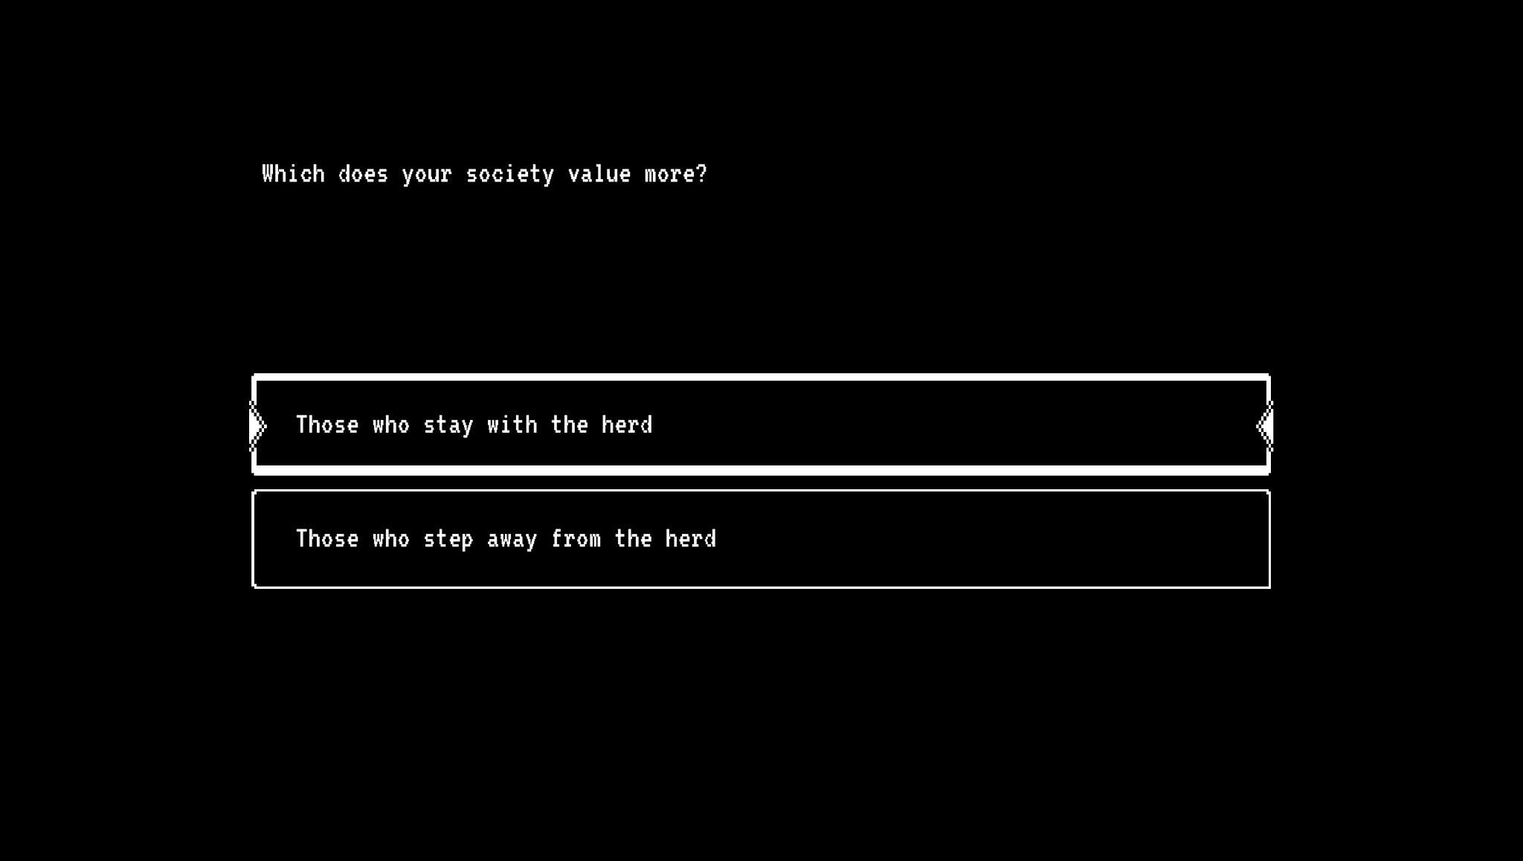

Episode 1: The Protest
On Fannyside Farm, the afternoon before the Protest, Old Ass requests that Trusty Ass visits each member of the herd of donkeys to ensure the morale of the group is high.
Trusty visits:
- Big Ass (who puts things into perspective)
- Smart Ass (who is the strategist)
- Sturdy Ass (who is the next-in-command)
- Nice Ass (who is the fastest and loves plowing the field)
- Thirsty Ass (who is onward-looking)
- Slow Ass (who is well-intentioned but has arthritis)
- Sad Ass (who is mourning his lover Lazy who died in the mines)
- Bad Ass (who is a radical that wants to be left alone)
After talking to everyone and successfully raising morale, Trusty returns to the barn to rest. At dawn, Trusty is awakened by a dying Old Ass who claims that during the night he escaped from Humans trying to euthanize him. He charges Trusty with the responsibility of carrying out the Protest—then dies.
Trusty recruits the other donkeys on the farm—all except Sad Ass and Bad who stay behind. The Herd leave the farm and meet the Mining donkeys on the road to the north:
- Kick Ass (who is angry and impulsive)
- Sick Ass (Kick's sister, who communicates only by coughing)
- Hard Ass (who is strong, stoic, and blunt)
The group marches on the village to protest, however, when they arrive they find the village is on fire.
WARNING: At this moment in the game there are loud sounds of screams from the Humans in the Village. They are exaggerated and (sometimes) funny but also may be disturbing.
The Herd goes to get water from a well, but it is dry. They turn to Trusty for a moment of leadership and just as she is about to say or do something inspiring, she falls into the well and dies.
WARNING: When Trusty falls down the well, loud music plays and there is a video sequence containing an extended scene of flashing black text on a white background. The game transitions from a 2D pixel art world into a 3D world.
Trusty’s spirit receives a message from “The GODs” and is transported to the Astral Plane, landing in a beautiful and mysterious field of red flowers. After exploring, she finds a group of Asses who perform a Welcome Ritual with her.
WARNING: During the Welcome Ritual loud rhythmic music plays.
A scene from Episode 1 looks like this:
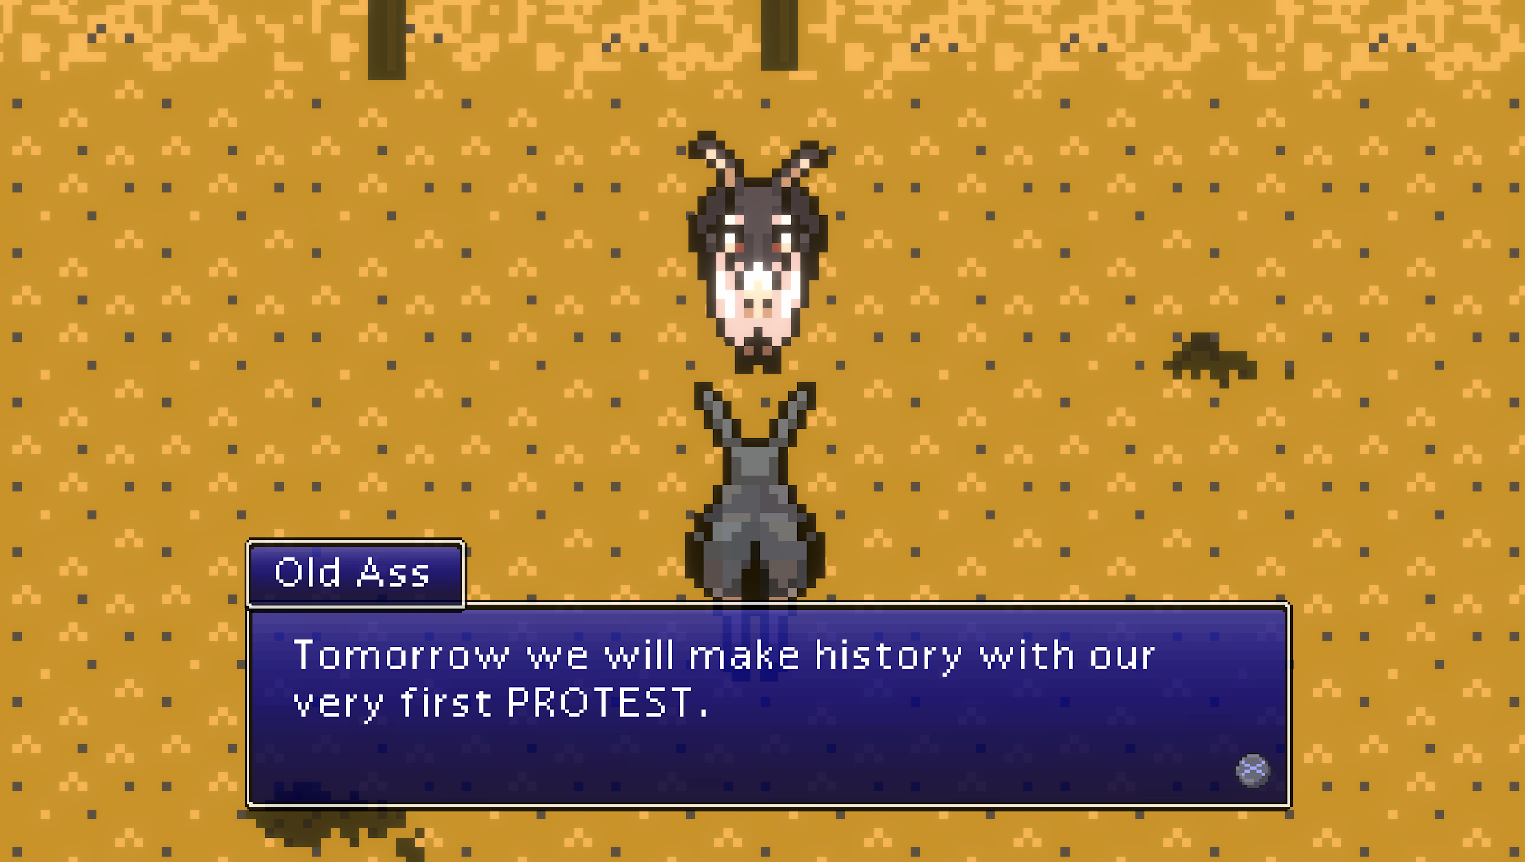
And when the game moves into the 3D world it looks like this:
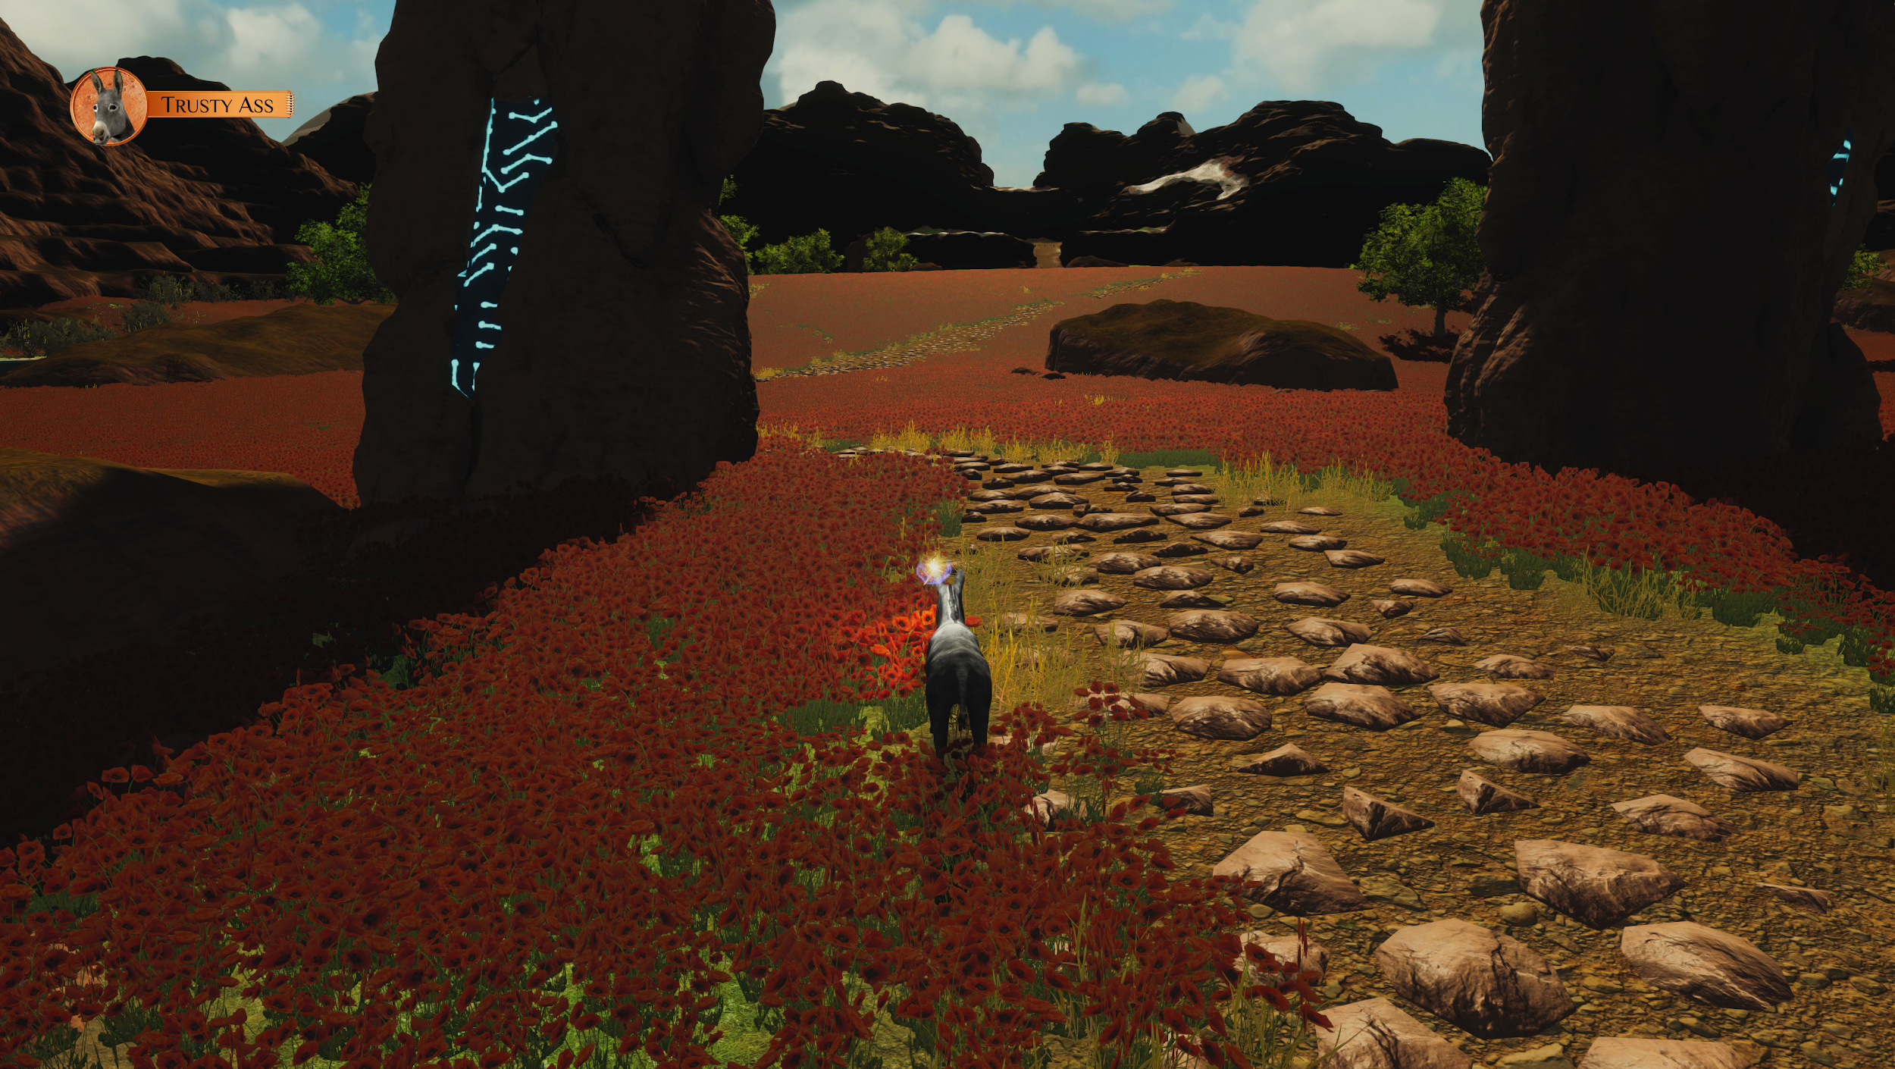

Episode 2: The Fire
Back in the Village of Bumpkin, immediately following Trusty’s death in the well, the protesting donkeys are panicking. The fire is spreading towards Fannyside Farm, and the humans in the Village are in danger.
Nice Ass runs back to Fannyside to warn the others, while Hard Ass goes to rescue the Humans. Slow Ass chooses to stay by the well to perform the Song of Ascending for Trusty's soul. The rest of the Herd rush to the river to get water to put out the fire.
Upon arriving at the farm, Nice Ass grabs her plow to create a fireline in order to stop the spreading fire. While plowing, she hears Sad Ass hiding in the Outhouse and rushes to save him
Hard Ass, meanwhile, known to be the strongest within the herd, is tasked with pulling the Humans from their houses in the burning Village of Bumpkin.
WARNING: As Hard Ass looks for Humans there is the sound of loud screaming.
In each house he enters, Hard Ass realizes that, despite all the years of working side by side with donkeys, the Humans now value their machines more than the lives of Asses. Hard Ass decides to stop trying to rescue humans and instead make sure they perish in the fire.
Hard finds the boss of the Mines, Mr. Hugh G. Butte, in a drunken stupor, monologuing about his misfortune about the Mine having gone bankrupt and his son, Cole Butte, having tragically died in a cave-in one year ago; the same catastrophe that took Lazy Ass's life. Hard Ass attacks Mr. Butte and kills him.
After the fight, Hard Ass turns to leave the house. However, the house’s burning roof unexpectedly collapses on Hard Ass and in the process, he loses an ear.
Back at Fannyside Farm, Nice Ass has learned that Sad Ass was the cause of the fire, intending only to set one car on fire, the whole village ended up in flames. Nice convinces Sad to leave the Outhouse just as it begins to rain. Nice promises to keep Sad’s secret about setting the fire and provides an uplifting speech about what is to come, not knowing that the fire has ravaged Fannyside Farms and the Village of Bumpkin leaving not a single one of the Human villagers left alive.
A scene from Episode 2 looks like this:
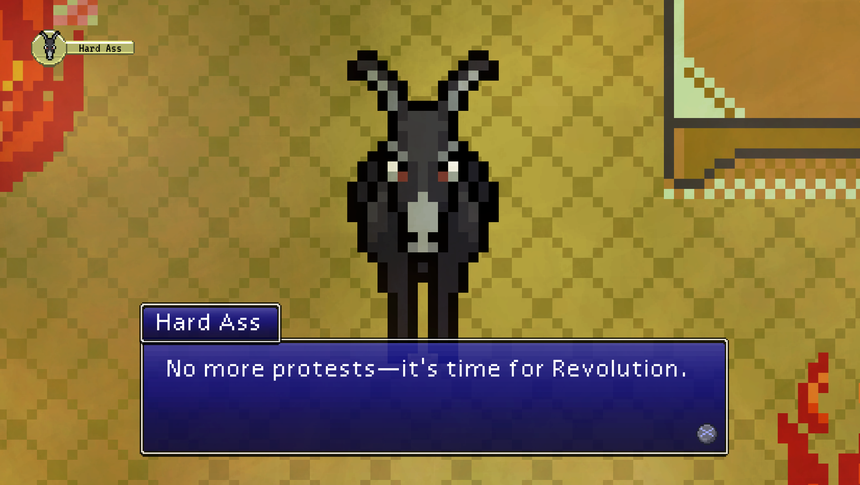

—Intermission—
The title card for Intermission looks like this:
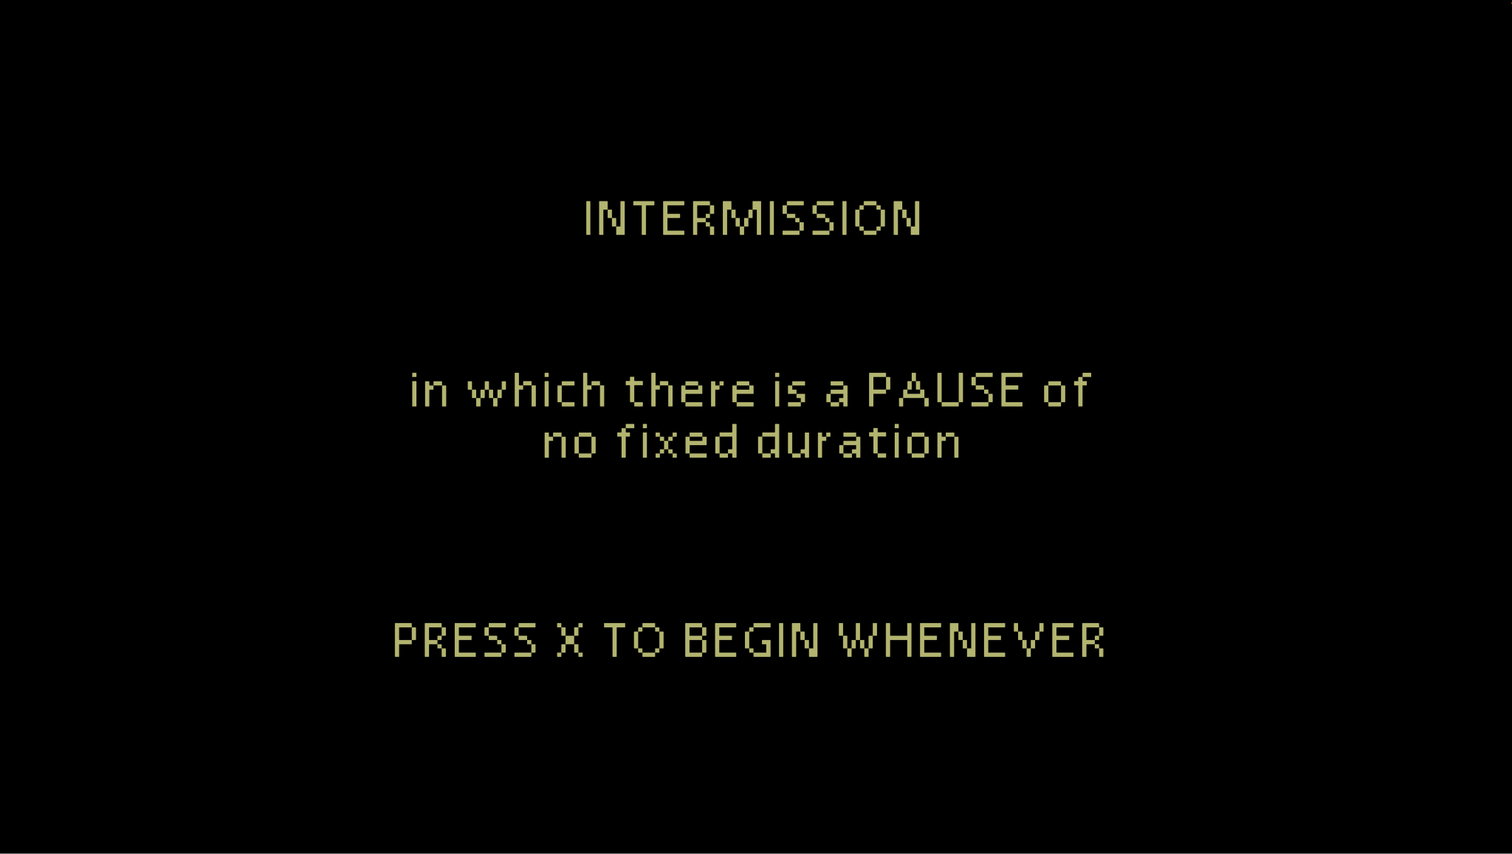

Episode 3: The Mine
Three weeks after the fire, the rain has not stopped and the river has flooded.
Over in Butte Mines, the Herd is holed on the first floor to protect themselves from the elements. The Asses are hungry and dependent on a scavenging team consisting of the Mine Asses (Hard, Kick, and Sick), to get food for everyone.
Meanwhile, Sturdy’s young Foal, born the night of the failed protest and the fire, is complaining about being trapped inside. Having no knowledge of Humans or life before the Herd's days in the Mine, the Foal finds her sheltered life to be incredibly boring.
Sturdy lectures the Foal about the importance of true work. She also uses the death of Lazy (The Foal’s older half-sister) as a warning to the Foal about the danger of Machines and being on the bad side of Humans.
When Hard, Kick, and Sick return, the Herd asks if the scavenging team found any Humans. The scavengers say that they have not seen a single Human. Hard Ass suggests they should forget the Humans and be their own Masters. Smart Ass argues against this. Sick doesn’t feel well and collapses. The grown up Asses try to figure out what to do next and send The Foal to go play.

The Foal attempts to get the other Asses to watch her play her favourite game: Rocks.
Each Ass she approaches, however, is too preoccupied with debating whether to stay in the Mine or leave to find Humans to work for.

WARNING: There is loud rock music of various genres that plays during the
game of Rocks.

While exploring the Mine level and ignoring Sturdy’s wishes to not touch Machines, the Foal eventually opens a path to the lower levels of the mines by pushing a minecart through a boarded up tunnel. Descending deeper into the Mine, the Foal navigates the tunnels and discovers remnants of the Humans in the Mines and their Machines. She also finds the ghost of her sister Lazy.
At the bottom of the Mine, the Foal finds Bad Ass alone in a room filled with computers and other technology pulled from the remains of the Humans’ homes. Bad Ass is playing a computer game and the Foal asks Bad Ass if they can play too. After the game, The Foal asks Bad Ass if she can stay down in the Mine with him rather than go back up.
Bad Ass agrees, telling her that he could use an ‘assistant’.
A scene from Episode 3 looks like this:
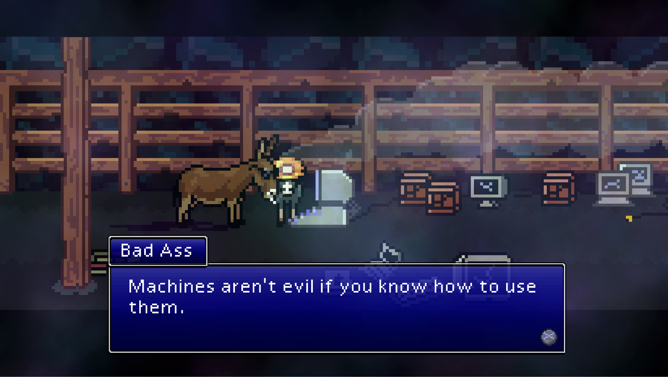

Episode 4: The Path
Back on the first floor of the Mine, Sick Ass wakes up from a dream, collapses, coughs, and dies.
Grief stricken by the death of her sister Sick, Kick Ass breaks down and the herd gathers around Sick's body. Kick Ass reveals to the rest of the Herd that the Scavenging team wasn’t just getting food each day; Hard Ass was also making Kick and Sick help kill off any and every Human that tried to return to the village. Shocked and betrayed, the Herd demands answers from Hard Ass.
Hard Ass tells them that he killed the humans on the day of the fire. Smart Ass calls Hard Ass a monster, a liar, and says this betrayal is the last straw. She calls on anyone smart enough to follow her and leave immediately to go find work and Humans elsewhere.
The Herd splits into two.
Those who join Hard Ass (resistance against Humans, building Fannyside up as their sovereign territory): Sturdy, Nice, and Thirsty choose to stay in Fannyside.
Those who join Smart Ass (to find other Humans and retrain for new work). Big, Kick, and Slow choose to leave.
Sad Ass either stays or goes. This depends on the choices of the player.
The Herd back inside the Mines gives space to Kick Ass to perform the Song of Ascending for Sick Ass, allowing Sick’s Ass Soul to go to the Astral Plane.
Kick gives Sick a heartfelt goodbye, promising never to hurt Humans again.
Like Trusty Ass, Sick Ass’s soul receives a message from ‘The GODs’ and is transported to the Astral Plane.
Note: at this moment in the game we move from the 2D pixel art world back to the 3D space.
Upon arriving in the Astral Plane, Sick Ass is greeted by the donkey that Trusty mated with. They welcome her and say they’d normally perform the Welcome Ritual but they’re feeling quite exhausted because so many donkeys have come lately. Then Sick goes to find someone else who can initiate them into her new life on the Astral Plane.
As Sick explores The Astral Plane, the donkeys invite her to play and share in different games and activities: sex, racing, dancing, making music, puzzles, and a concert. Ultimately, like Trusty before her, Sick Ass decides to leave. She finds an exit through a filthy tunnel called the "Shithole" that the donkeys use to deposit their feces due to their large population. On the other side of the tunnel, she starts out across a long desert road, surrounded by clouds on both sides.
Warning: Racing games played in the Astral Plane contain disorienting visuals that could cause motion sickness. Mating games contain loud rhythm music. Depending on player choices, there is a concert featuring loud DJ music.
While she goes, more donkeys continue to fall from the sky as they enter the Astral Plane.
A scene from Episode 4 looks like this:
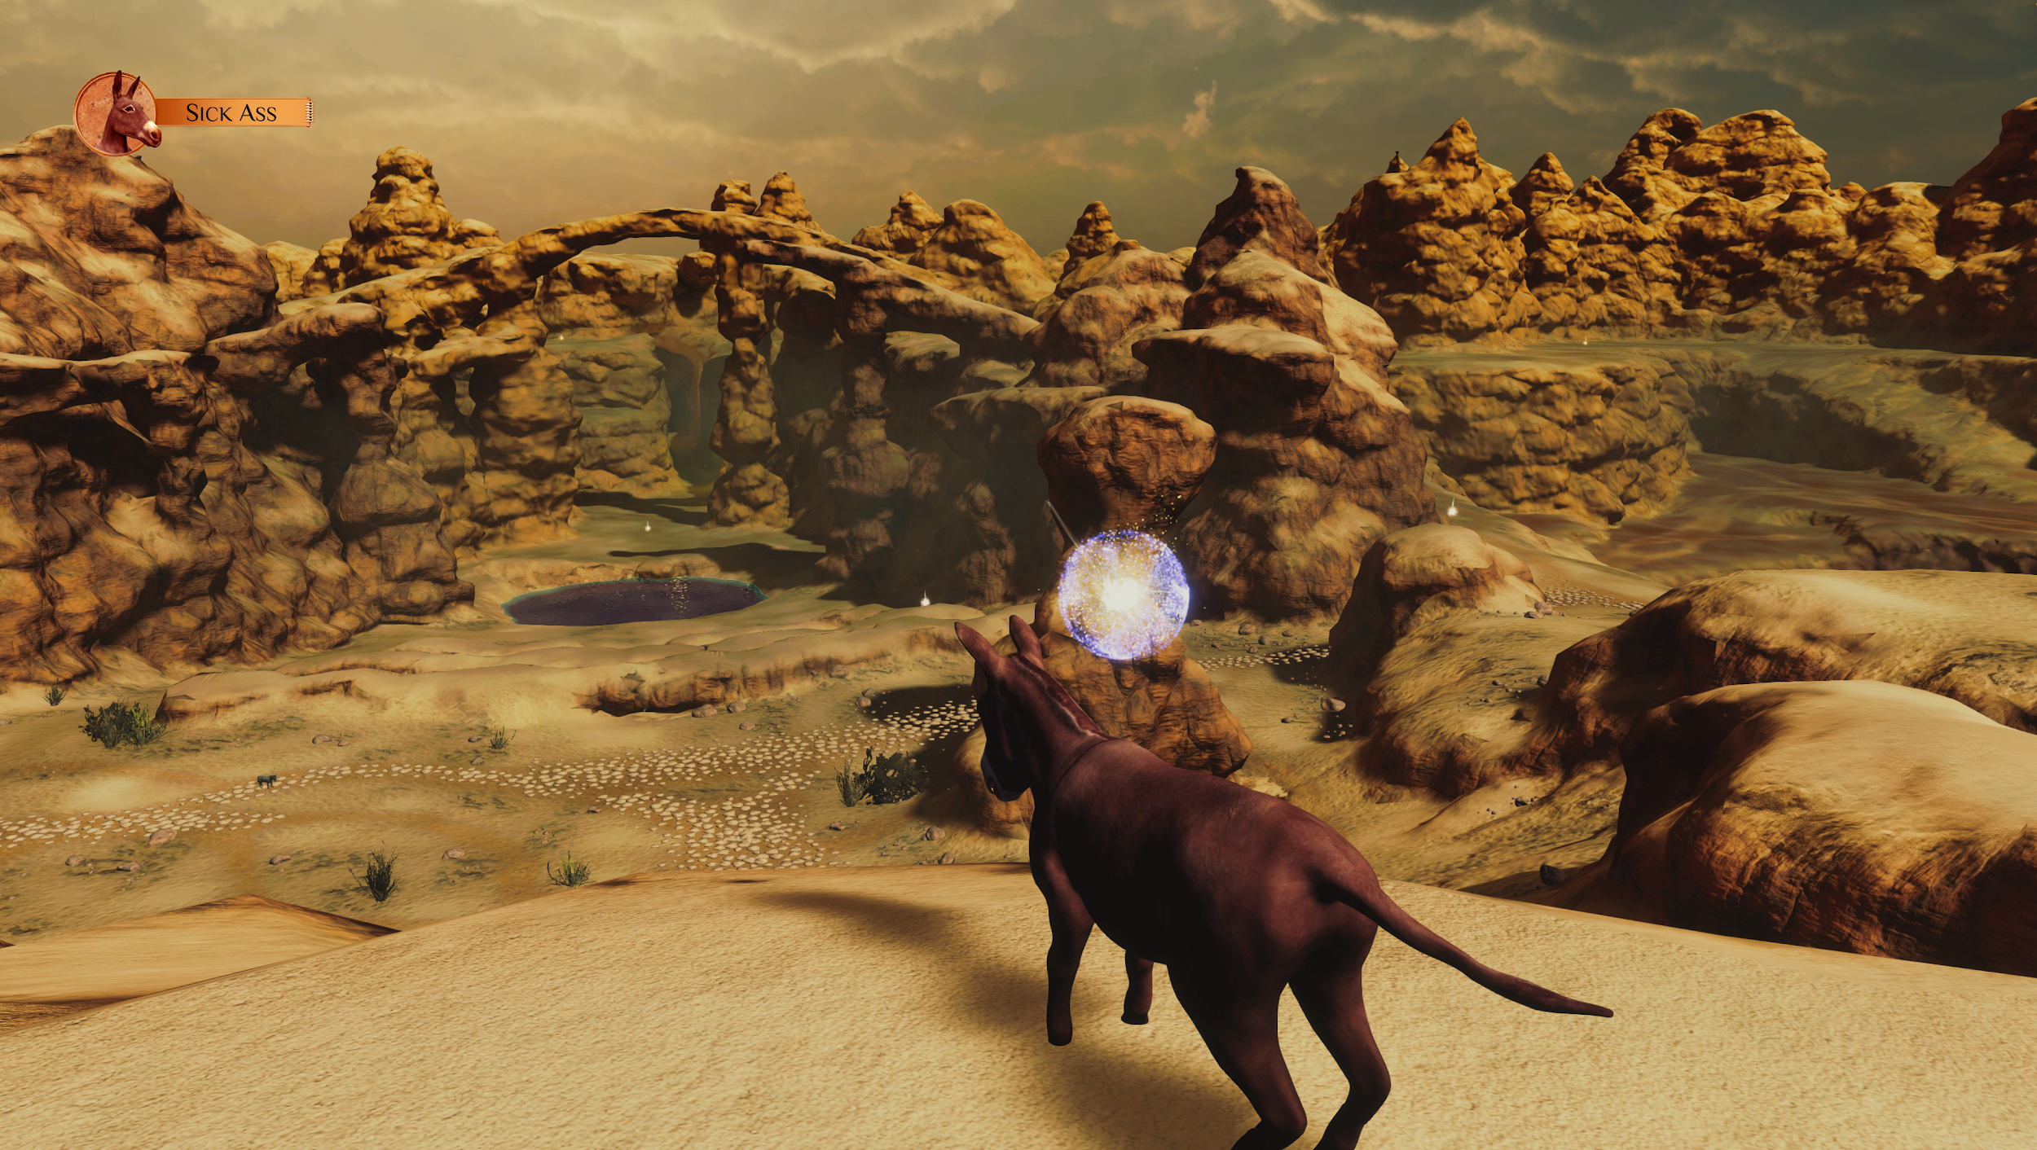

—Intermission—

The player gets to decide if they would like the donkeys who left Fannyside to go to the Zoo or the Circus to get new jobs. They will play one of these two levels:

Episode 5: The Zoo
6 months later, Smart, Big, Kick, Slow, and possibly Sad Ass are living at the Zoo, cared for by Zookeeper Rose. Rose calls the donkeys together and gives them a briefing about a new initiative called "Ass of the Week"— a ploy to incentivize them to work harder. She describes the Human guests that will be visiting and how the donkeys can satisfy them.
The donkeys are excited about the game and begin to show their competitive sides. Each day they compete until, after 7 days, Rose awards Ass of the Week to the winning donkey. But something is amiss. A truck arrives and the mysterious people from earlier days appear. They give Rose money in exchange for leaving the gate open for them.
Rose apologizes to the Asses but says she needs the money. She runs off.
The mysterious Humans, Melvin and Wedgie, then try to capture the donkeys. The Asses run into the pen to hide.
Everyone is captured except for Slow Ass, who must follow the truck and rescue the others.
Note about Sad Ass: If present, Sad Ass will leave the Zoo at Day 6. Being at the Zoo makes him upset. He says the Herd aren't Comrades anymore, just competition.
A scene from the Zoo looks like this:
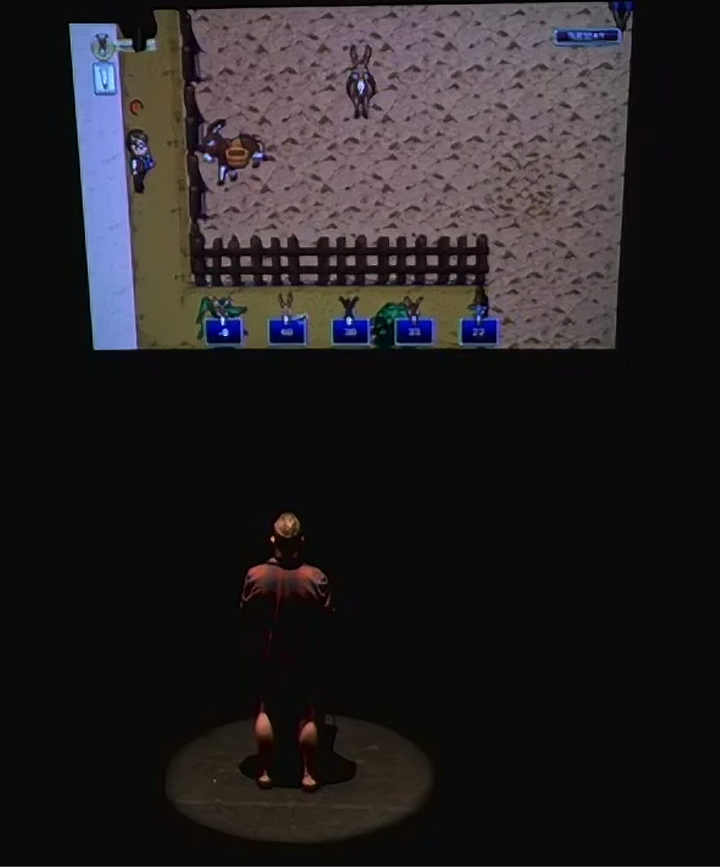

Episode 5: The Circus
6 months later, Smart, Big, Kick, Slow, and possibly Sad Ass are working at the Circus.
Inside a big circus tent, lights, and fanfare abound. The episode begins with the jubilant Ringmaster Rico welcoming the audience and baiting them with an exciting announcement to be shared at the end of the evening's show.
Each Ass gets their chance onstage to perform a variety of tricks. They are dressed in costumes to resemble other animals: a Gorilla (Smart Ass), Elephant (Big Ass), Zebra (Kick Ass), Bear (Sad Ass), and a Lion (Slow Ass).
After the performance, Rico tells the crowd that he's retiring the animals. He claims he's going to be getting new animatronic performers, the likes of which the performing arts have never seen.
Slow Ass runs offstage to find Rico taking money from some mysterious people, Melvin and Wedgie. The other Asses are already tranquilized and in their truck. Rico says goodbye to Slow Ass as he leaves to head back to the stage.
Everyone is captured except for Slow Ass, now dressed as a Lion, who must follow the truck and rescue the others.
A scene from Episode 5: The Circus looks like this:
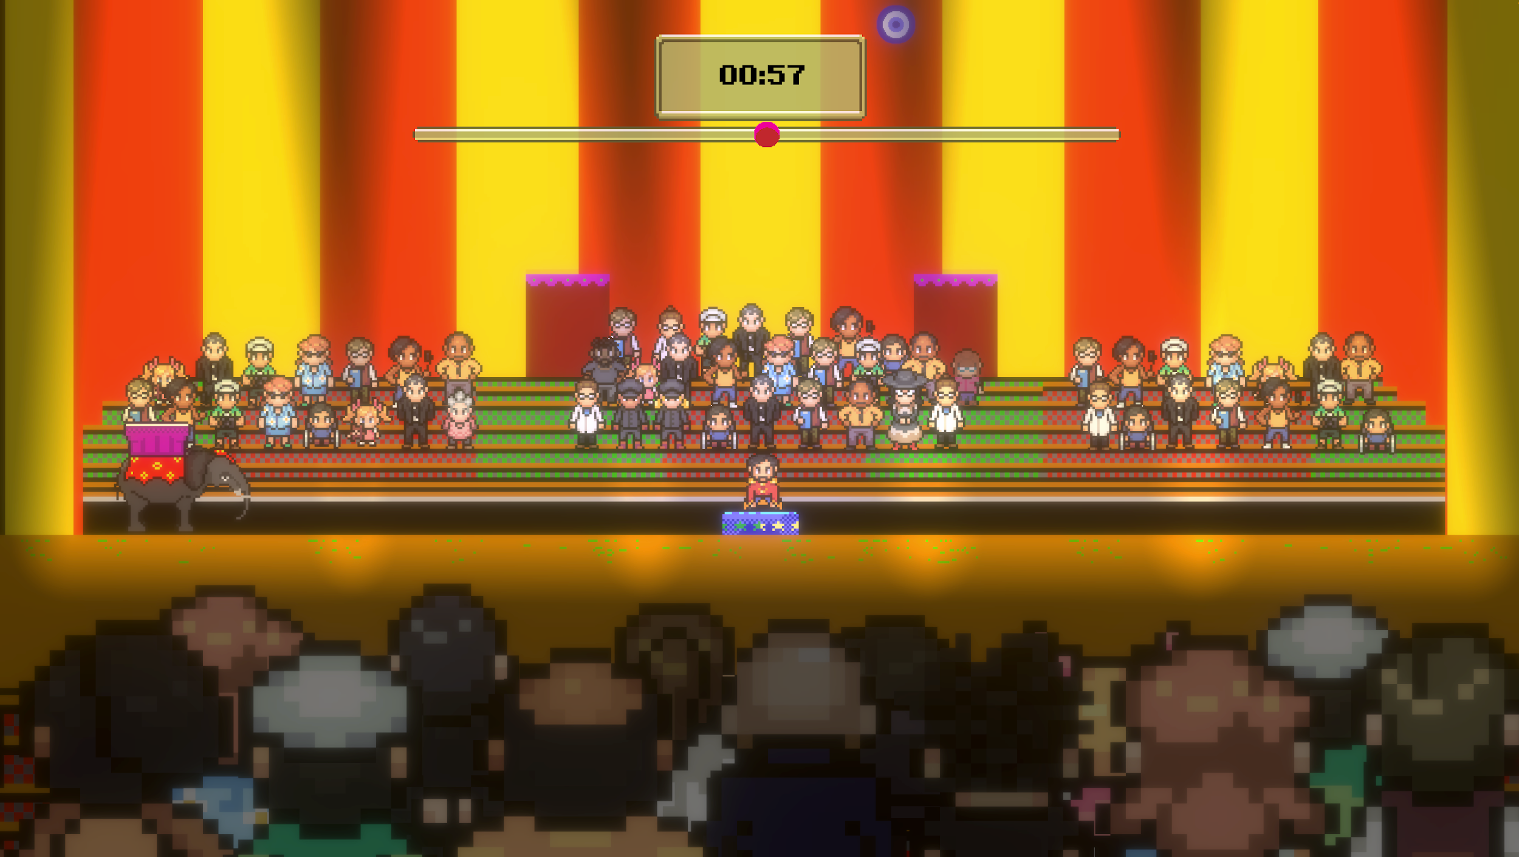

Episode 6: The Dream
WARNING: The beginning of this episode begins with very loud noises (indistinct crashing and fighting sounds) while the screen is dark.
Hard Ass is having a nightmare that he is back in Butte Mines on the day that Lazy died in the cave-in. He relives the accident, leaving Lazy to be crushed by a boulder. Hard Ass battles monstrous versions of himself and the other asses who blame him for what happened.
Hard is met by Sturdy Ass upon waking. 6 months have passed on the farm. Since the Flood subsided, the area has entered into a state of rewilding. The world is rugged, bright, and peaceful.
Sturdy Ass criticizes Hard Ass for napping while on guard duty. He has to defend the road to the Farm by killing any Humans who try to approach.
Sturdy is spending quality time with Foal and they take the path back to the Village. When they arrive, the Foal asks to go to the Theatre. The player decides whether or not Sturdy allows the Foal to go inside the Theatre.
The Foal, after going inside or not going inside the theatre, leaves to go see Bad Ass. Sturdy, now alone, explores the Village of Bumpkin in its rewilding state. Feeling abandoned by The Foal, she constructs a series of public art sculptures using some of the remaining debris from the fire and gives them names.
Sturdy wanders back to Fannyside Farm and meets the others. She finds Thirsty Ass who has just opened a bar called ‘Bottoms Up’ that serves all different kinds of water. Sturdy builds a sculpture for the bar out of nearby debris.
The other Asses come to the Bar, and just as a party seems about to start, Hard Ass arrives followed by Slow Ass who has made the long journey back to Fannyside with news that the others have been taken in a truck to a mysterious Factory, and they are in trouble!
Nice Ass acquiesces to an age-old rivalry and drives the Tractor, saying that they can make it to the city faster with a Machine. Everyone except Sturdy hops on to join the rescue mission.
Meanwhile back in the Mine, the Foal has gone to Bad Ass’s cave where she delivers a mysterious item she got from the theatre (or not). This is the last piece Bad Ass needed to complete his transformation machine.
As Bad Ass steps into the machine, he confesses to the Foal that his name is actually Cole Butte.
A Scene from Episode 6 looks like this: 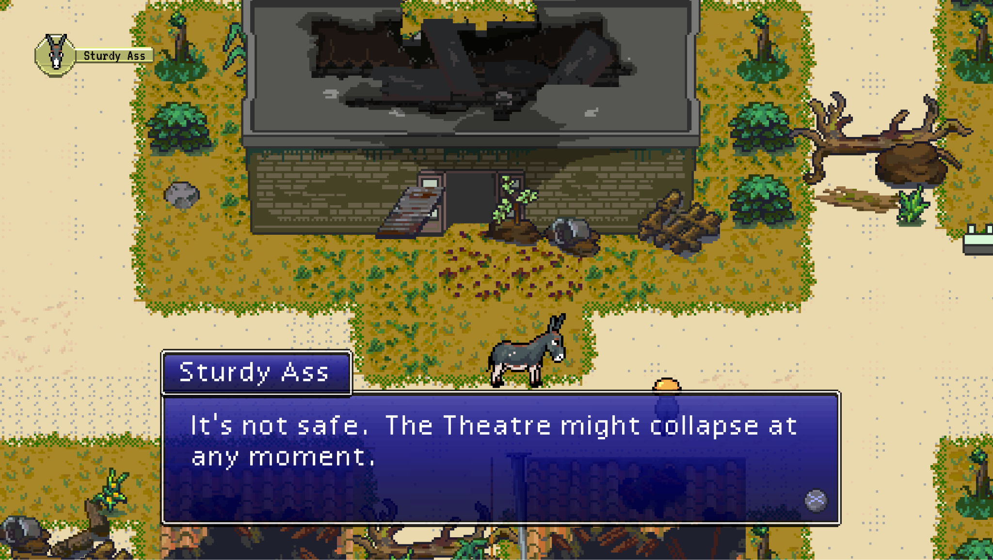

—Intermission—

Episode 7: The Factory
WARNING: The Factory episode contains many moments of suspense and
strategy where the game play is accompanied by loud music, gunshots, and sudden banging noises. The various levels in this episode are skill-testing and may need to be played multiple times to complete. Audience members often yell out and cheer loudly.

Two factory workers stand outside of the mysterious factory in Mecha City. Inside, Smart and Kick (and perhaps Sad Ass, depending on the branch of the game you are playing) wake up in the holding cells of the Factory.

Kick panics about Big Ass being missing. A donkey from a nearby cell tells them their friend is likely already dead. Around the room are scared and frightened Asses, all in holding cells.

Smart makes a plan. They break out of their cell, and go looking for Big Ass.

Our asses have to strategize and navigate their way through a variety of rooms in the Factory, each more daunting than the last. Along the way, they realize that the Factory kills donkeys, skins them, boils the skin, moulds it into a gelatinous brick, packages it, and sends it out. They rescue Big Ass from being killed and exposed to this fate.

At the exit after barely making it through the Factory, Big asks about the other donkeys left behind in the Holding Cells. Smart reveals that her plan all along has been for them to just forget about what they've seen and go back to their lives, finding good Humans to give them jobs again.
Big Ass is committed to making a difference now and refuses to go ahead. Smart Ass and the others are forced to leave for the exit, while Big Ass heads back into the Shipping room to free the rest of the asses being held at the Factory. After destroying the control room and releasing the captive asses, he either leaves the Factory or ventures into the Robotics Lab to face off against Mme. Derriere and her fleet of automated workers.
WARNING: Loud music and sound effects play during this battle.
In this optional boss battle, Big either loses and dies, or he succeeds in making the faulty robots explode, thereby blowing up the Factory, after which he escapes along with the other freed asses.
A scene from Episode 7 looks like this:
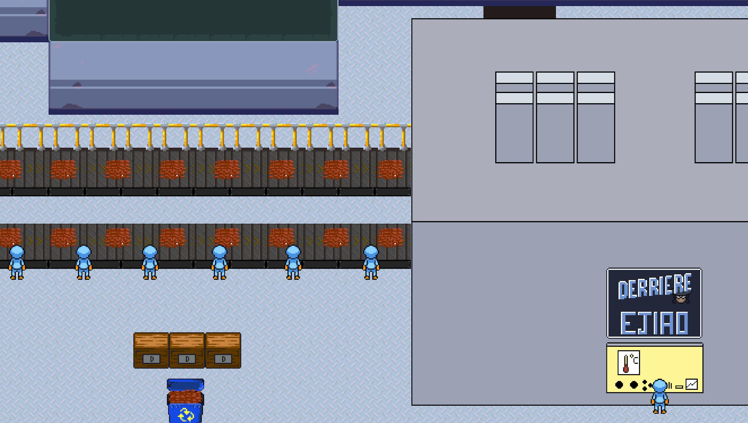

Episode 8: The Sanctum

WARNING: The opening of this episode involves navigating a path in a 3D environment. This may cause some audience members to experience disorientation or feelings of motion sickness. There are loud sounds of hoofbeats whenever the Ass walks.
Back in the Astral Plane, Sick is at the end of the long road we last saw her on. She crosses the remaining floating road and then finds herself at the Holy Sanctum, a floating ancient rock with mysterious stone structures and carvings.
In the middle of the Sanctum, she finds her old Comrade, Trusty Ass. Trusty explains that she can't stay in the Astral Plane and needs to find a way back to continue being the Leader of the herd. The two donkeys work together to solve the puzzles that summon the portal back to the living world.
When they solve the final puzzle, Trusty and Sick enter a large empty space with a glowing blue cube. The Gods then awaken and appear as a giant two-headed donkey.
WARNING: In this sequence, as the cube appears, there is very loud music and sound effects.
The Gods talk to Trusty and Sick Ass explaining the Soul’s Reassignment process. After saying goodbye, Trusty Ass’s soul is reassigned. The Gods then explain that Sick Ass has been chosen to be the next Golden Ass, a special donkey chosen by the Gods to be their avatar in the world of the living.
Sick Ass is then swallowed by the Gods, after which they decide their next move against the Humans will be something called “Operation Prophet”.
A scene from Episode 8 looks like this:
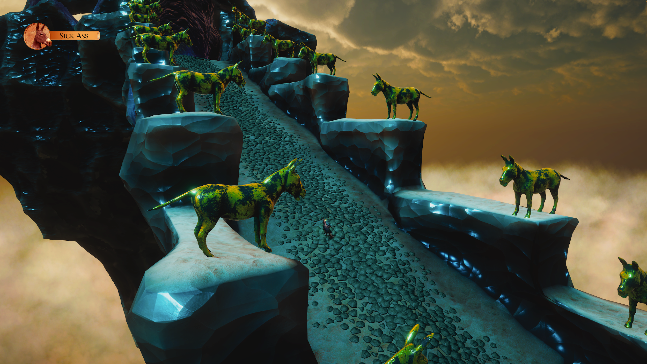

—Intermission—

Episode 9: The Machines
Back at the bottom of Butte Mines, in a Machine, Cole Butte's childhood and life flash before him. Cole's soul floats in a liminal, tunnel-like space—it's inside of the Transformation Machine's piping.

WARNING: There is a mini game sequence at the beginning of this episode that contains 3D movements and bright flashing lights.
Back inside of Bad Ass's Cave, the Foal is excitedly standing outside of the Transformation Machine.
Suddenly the Machine dings and its doors open revealing a humanoid Android. The Android—Cole Butte—steps out of the Machine and he rejoices that he is no longer a donkey. The Foal asks if she could also become a Machine. Cole agrees and lets the Foal use the backup Android body.
Sturdy arrives and tries to stop her, but is too late and watches helplessly as her Foal’s soul is transferred into the body of a machine.
The Mine starts to rumble and cave in. The Machines carry Sturdy out. The mine collapses.
The trio finds themselves in a large crater, in the middle of which is the glowing Golden Ass, who explains they are on a quest to find the next Prophet for their operation.
The Player decides: will the Prophet be Bad Ass or the Foal, both now in the bodies of Machines?
Whoever is chosen flies away on the back of the Golden Ass, leaving Sturdy with the other Machine.
A scene from Episode 9 looks like this:

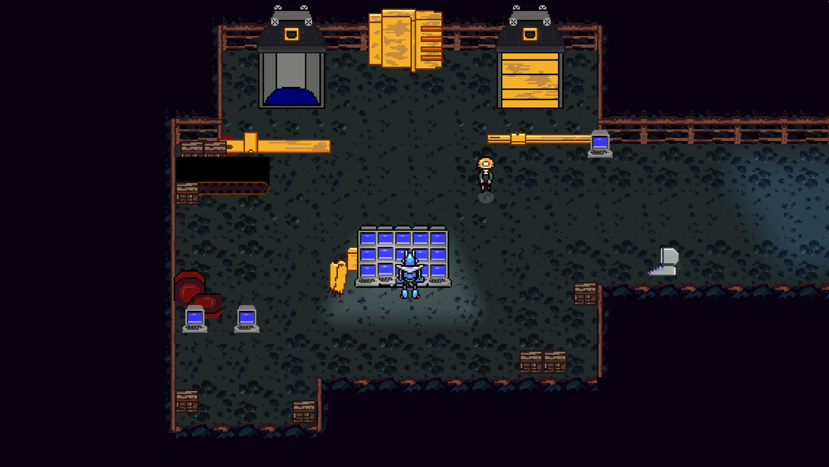

Episode 10: The Riot

The Tractor carrying all of the asses from Fannyside Farm arrives in Mecha City and finds its streets filled with other donkeys in the middle of a riot. Windows are broken. Cars are on fire. Donkeys are running this way and that way. Civilians and Police are running and screaming, with weapons drawn. The donkeys fight their way to the Parliament and hide inside.
WARNING: Loud music, donkeys braying, and sound effects play during the fight scenes that begin this episode.

The asses are occupying the Parliament when suddenly the Prophet and the Golden Ass appear. The Prophet and Golden Ass collect the individual desires of the asses into a Manifesto to present to the Humans outside.
WARNING: Once inside the Parliament building, there is a sequence with loud pulsing music.

The Prophet gives a speech about their values. The speech is moving and inspiring. It catches the ears of civilians and even the police.

WARNING: There is a loud moment of gunshot.

Suddenly there is a shot and the Prophet falls to the ground. Mme. Derriere, the owner of the factory, holds a gun and gives a counterspeech. At the end, the police begin firing at all the donkeys.

WARNING: Multiple gunshots and flashing lights on the screen.

The screen fades to white.

A scene from Episode 10 looks like this:
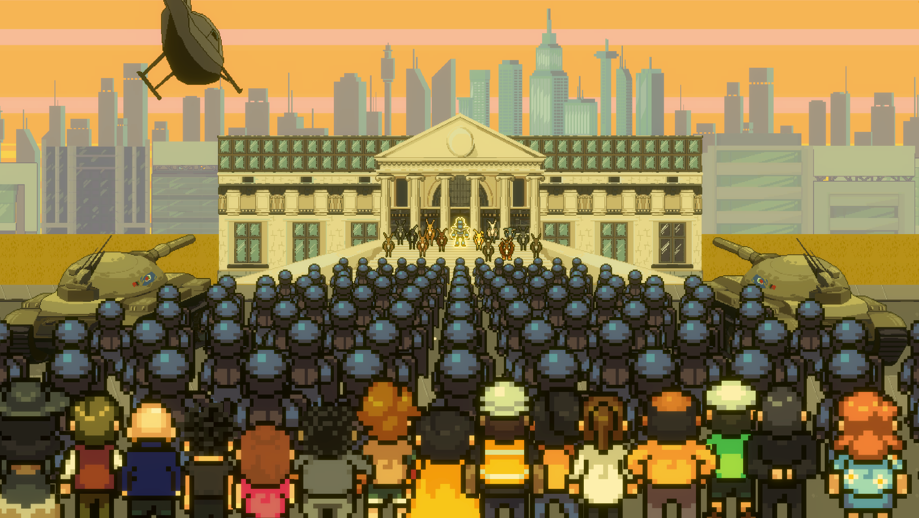

Epilogue
Black handwritten words appear on the screen and an illustrated donkey jumps from word to word, continuing the story.
WARNING: White screen is bright and black words are written in cursive script.
The story tells of how the donkeys who died that day were sent to the Astral Plane and there rallied the apathetic Great Herd to give up their comfortable lives of pleasure and return to the world to fight against Human Imperialism.
The story concludes as it fades in on Sturdy Ass, now older, finishing her story in front of a group of other barnyard animals.
The Machine (either the Foal or Cole Butte, depending on the player’s choices) appears. It’s time for them to keep walking, to tell their story at the next farm and spread the revolution across the countryside.
A scene from The Epilogue looks like this:

